ECE 312

Lab 8

Frequency response of BJT amplfier

Student Name Signature

Majed Alharbi

Stephen

Abstract

input resistance and output resistance have a relationship with frequency that was neglected in the previous labs since we were using DC and AC analyses that is true only in the mid-band region. The low and high frequencies are the frequency that create the bandwidth where amplifiers work correctly, however, outside of these bands, frequency can make the output reduced to zero. The reason for that comes from the intrinsic and coupling capacitors in transistor amplifier.

Introduction

In this lab, the relationship between frequency and gain will be studied both theoretically and experimentally. This will be done by creating an amplifier and then reduce the input frequency until we reach the low cut off frequency, and then the input frequency will be increased until we reach the high cut off frenum.

**Theory and Analysis of the circuits**

The previous labs, we had made an assumption that the small signal gain, input resistance and output resistance were independent of frequency, because of the DC analyses we have assumed all the capacitors at open while in AC analyses we saw them as a short circuits. In the previous amplifiers we have assumed that the gain is constant over all the frequency, however that is only true over the mid-band frequencies as shown in figure 1.

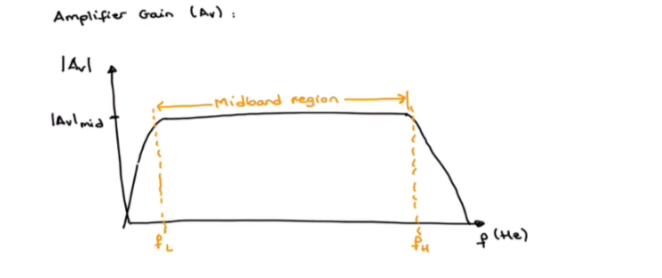

The low and high cutoff frequencies are the frequencies where the mid-band gain falls 3-dB bellow mid-band region or the maximum value, or -3dB, and we can see that the bandwidth is FH-FL. the reason why the gain fall in the low frequencies is the coupling and bypass capacitors, while the reason for the fall at the high frequencies is due to the wire capacitances, internal BJT capacitances, and the load capacitances. The coupling and by bass capacitor producing a response that is a high pass response. Figure 2 shows the resistances and the capacitances associated with an amplifier.

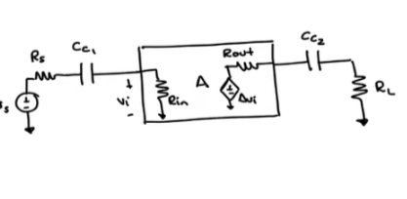

Taking the Thevenin resistance in the left hind side by shorting the voltage source we find that the two left resistors are in series as they both connected to ground, hence, the cutoff frequency interduce by the left capacitor is . And similarly the cutoff frequency interduce by the left capacitor is . These cutoff frequencies are found by the basic analyses of fist order RC circuits. The next step to find the dominant cutoff frequency which will be done by calculating each cut-off frequency indecently with shorting all other capacitors and then choosing the largest cut-off frequency since it will be the closest to the full gain of the amplifier.

For the high frequency response, the gain get reduced due to the internal, story, and load capacitances. These capacitances will form low pass filters and similer to the previous analyses. Each cut-off frequency will be found, however this time the lowest cut-off recusancy will be the domenant since it will be the closist to the full gain of the amplifier. In bjt, the most important capacitors are the capacitance from base to collector Covo, and another capacitor from base to emitter Cibo­.figure 3 shows the capacitors in small signal model as well as in the BJT symbol.

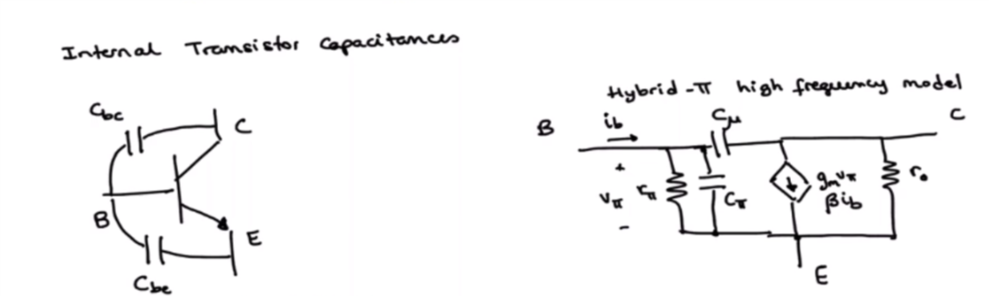

Figure 3

There are other things that will affect the high frequency response, these things are the resistive load, the capacitance due to the load, and Mellor effect. There load resistance and capacitance does not have a large effect, however Mellor effect does. Mellor effect states that when a capacitance is connected between the input and the output such as in CE amplifier, the result is smiler if there were two capacitors in the circuit one for input and one for output and their values are shown in figure 4.

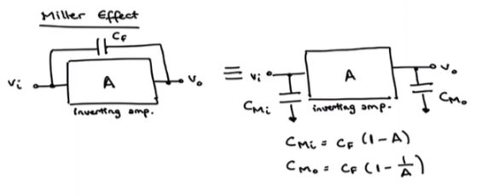

This was a general introduction and theory for the frequency response analyses of the circuit, however for the circuit that will be studied in this lab, the analyses will be done quantitively.

**Methods**

The circuit in figure 1 was built with an input voltage of 400 mV peak to peak, and the input and output voltage were generated in order to find the gain and compare it to the pre lab results. Then, the input frequency was reduced until the output was .7 times the previous output in order to find FL. Lastly, the frequency was increased until the output again reach 0.7 times the old value in order to find FH. The results shown in the next section of the report.

**Results**

\ 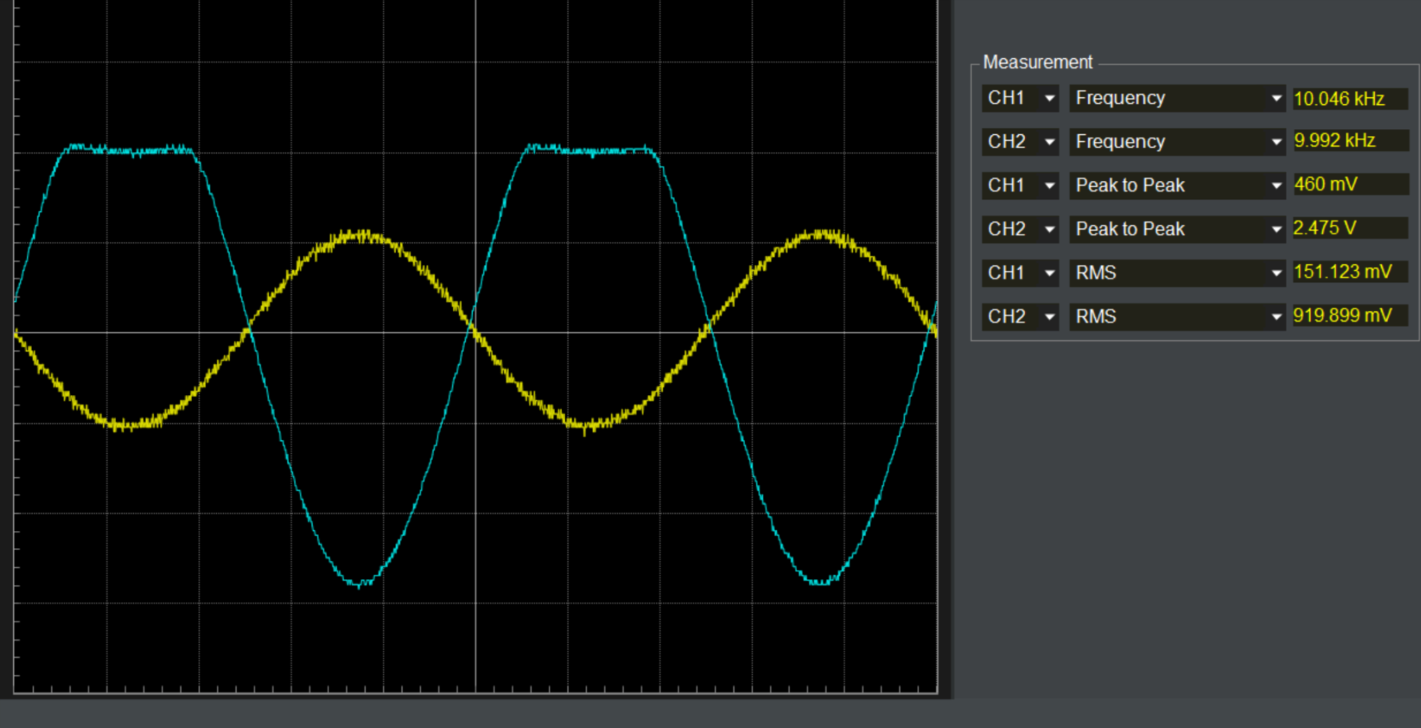

The output before reducing or increasing the frequency

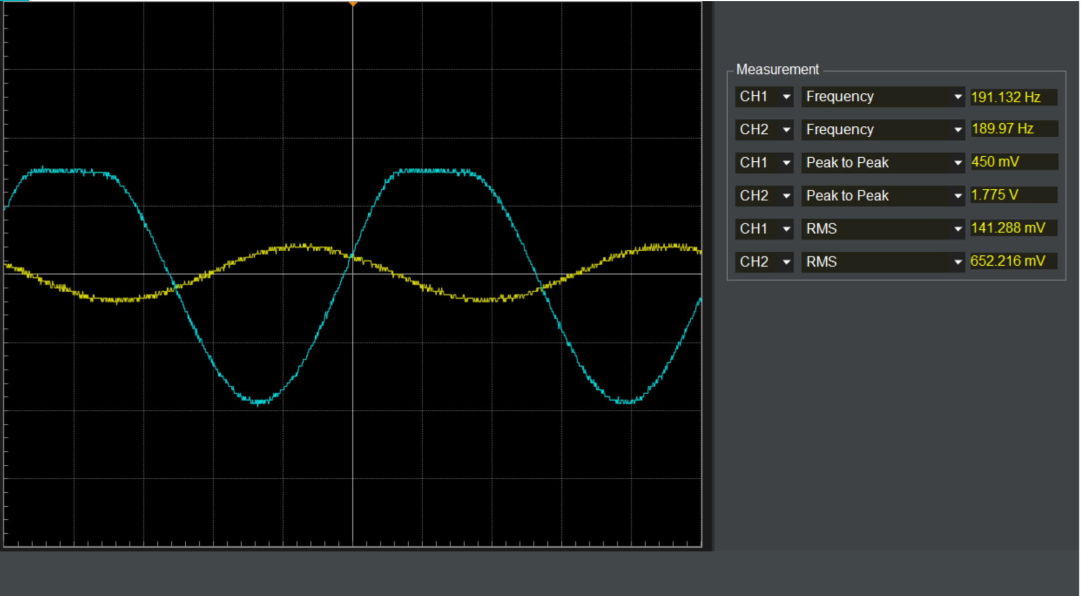

The output after reducing the frequency

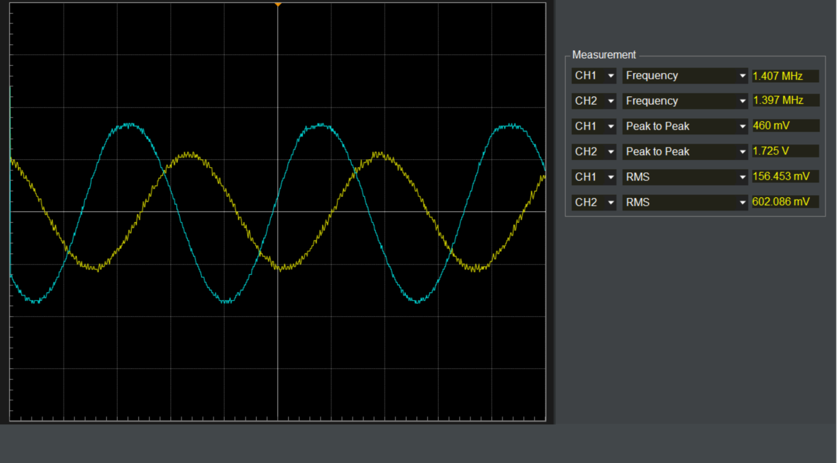

The output after increasing the frequency

**Discussion**

The output of the circuit was 2.4V as can bee seen in figure 1. In order to reduce it 70% of its original value, it should be 1.7V. the frequency that cause the output to reach this value was 191 Hz. Although this was not as the results that was found by Dr. Rancour pre lab solution, it still shows the effect that the frequency has in the output, as the output got reduced out of the mid-band voltage. then for the second part, the frequency was increased until 1.4 MHz, which cause the output to be 70% of its original value, which also shows the effect of frequency on the circuit. Although the results were not as expected, but the effect of frequency that was explained in the theory part of the lab have occurred.

**Conclusion**

In conclusion, this lab shows that capacitors can not always treated as short in AC circuit or as an open in DC, as sometimes they will have significand effect on the circuit.

Reflection

The lab went smoothly and as expected, however we were not able to use the exact same V2 voltage, hence, it was tweaked a little bit.

References

1: Sedra, A. S., & Smith, K. C. (2009). *Microelectronic circuits: Theory and applications* (5th ed.). New Delhi: Oxford University Press.

2: Dr. David Rancour lecture notes

**Appendix** F